
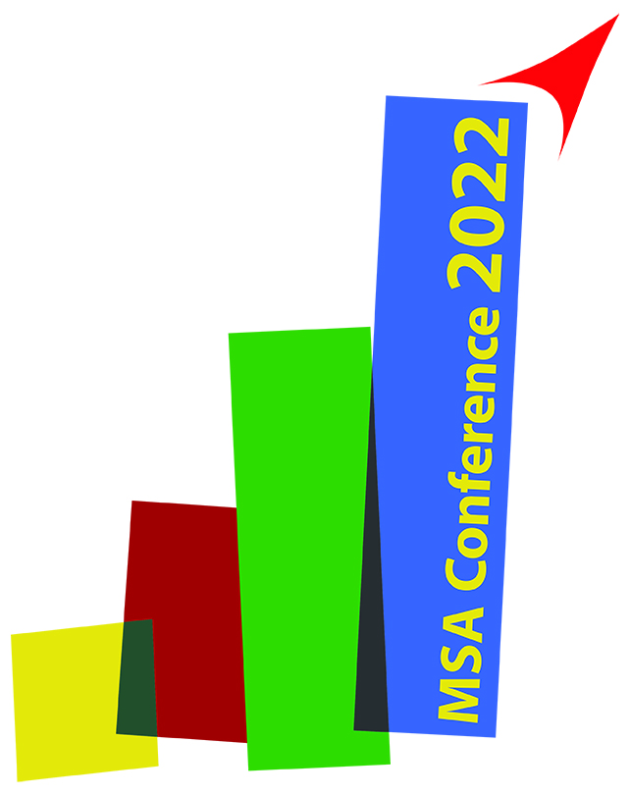

MSA – Young Researchers Award Verification

(For valid application hand in prior to 15th March 2023)

To participate in this years’ Young Researchers Award (YRA) the applicant,

(please print) Ms/Mr: MSA Ref.No: University/Faculty: City/Country:

fulfils all following criteria:

The researcher is a student/PhD student or graduate less than 2 years after the PhD.
  - The researcher is 30 of age or younger at the time of the conference. (born after 5th April 1992)
  - The researcher has made an independent and reasonable contribution to

the work submitted for presentation.

  - The researcher has paid MSA Membership 2020 before 15th March 2023.

As applicant for this years’ Young Researchers Award I have read and understood the above listed YRA requirements and herewith confirm my compliance.

Date/signature – YRA applicant

As head of institute I, the undersigned, have read and understood the above listed YRA requirements

and herewith certify that Ms/Mr

(please print) fulfils all above listed

requirements to be accredited for this years’ MSA Young Researchers Award.

Official stamp of University/Faculty Date/signature – Head of Institute

Please note: For the final acceptance of your YRA application the following criteria need to be fulfilled as well!
- MSA Membership 2022 needs to be paid before 15th March 2023

- Conference registration fee paid before the deadline of registration for presenting authors
- Only one abstract has been submitted as first author to apply for YRA

- As previous YRA winner, you don’t take part in the same category again (Oral/Poster)
(e-mail to office@csakademija.me or fax to +382 40 235 200)

Montenegrin Sports Academy Đoka Miraševića 1/10, 81000 Podgorica
phone: +382 40 235 207
fax: +382 40 235 200
office@csakademija.me www.csakademija.me

